CSCI222 Assignment 1 Report

Team Number : <C1>

 | Student Number | Name | Email Address
1 |  | (Team Leader) | Tel :  Email :
2

3

4

5

6

Table of Contents requirements

This SECOND page is to contain the heading "Contents" and an index built using the insert table of contents facility in Word

(insert the page and heading at this stage and then insert the table of contents when the rest of the document is complete).

Tip: To start off, you can research the Insert | Reference | Index and Tables (in Word 2003)

Project Overview

In this assignment, the primary focus is targeted at the ability to provide a warehouse inventory management system for the user. This system is crucial as it will strive to streamline processes and optimise productivity and day-to-day operations. Staff members are able to make use of the provided summary data to conduct critical decision-making operations that will directly impact the organization.

It is therefore paramount for the organization to have an effective system in place with an effective security coverage, pinpoint accuracy for data summary and a robust system to maintain the highest uptime.

Examples of relevant information includes:

- "Vision"

- What is the general vision of the system's key features, core project's requirements and main constraints

- Initial Use-Case Model

- A "top-most" level use case diagram summarizing the system's interaction with all identified major external entities. Explain

- Project Plan

- Please refer to "Stud_GanttChart_Sample.xls" for planning your system development activities

- Overlay your RUP iterations to Gantt charts timeline (e.g. which phase-iteration relates to which week?

- Also, within each week, what are the development activities, start-end date, duration (no. of man-days), and who is in charge of each activity?)

- If you are pasting screen-shots of your project planning into this sub-section, please ensure all the wordings / text are clearly visible

(i.e. assume anything < Arial Font_Size_10 is NOT easily visible to your company's senior management!)

Roles and Responsibility

Team Number : <put your assigned team number here>

 | Student Name | Role | Artefacts
1 |  | < E.g. Manager, Designer, Systems Integration, Tester, Documenter, etc > | < E.g. Use Case Diagram, Report - Section 2, TestCase.h, TestCase.cpp, etc >
2 | Randy Tung Keng Guan |  | Class Diagram, Activity Diagram & Report
3
4
5
6

Risk Analysis and Counter Measures

For this section, you are to identify relevant risks and classify them in a table format as shown below. A sample (example) is shown in the first 2 rows.

Column Impact Type -
What is the type of impact affected by the risk?
E.g. Deadline/Budget/Successful Task Completion/etc.

Column Risk Seriousness (%) - how serious the risk affects the project

Column Likelihood of Occurrence (%) - how likely is the risk to happen

Column WBS (affected work/task) - the work/task id(s) in WBS affected by the risk

Column Risk Description - what is nature of the risk

 | Impact Type | Risk Seriousness (%) | Likelihood of Occurrence (%) | WBS  (affected work / task ) | Risk Description
1 | Budget | 80% | 5% | 1.3, 2.2 | All workers form a union to demand higher pay
2 | Deadline | 90% | 10% | 4.5, 2.1 | All workers resign in the middle of the project
3 | . . . | . . . | . . . | . . . | . . .

Based on the list of risks identified in above table, you are to outline a contingency plan of action to mitigate or eliminate the damage/impact caused by the risk

Column Risk Description - what is nature of the risk

Column Proposed Mgmt Plan - what is your plan(s) to reduce / eliminate the risk

Column (Possible) Reduction in Risk Seriousness (%) -
what is the possible reduction in risk’s impact, if the management plan is carried out?

 | Risk Description | Proposed Mgmt Plan | (Possible) Reduction in Risk Seriousness (%)
1 | All workers form a union to demand higher pay | Plan 1 : Offer whatever the pay demanded by workers | -50%
1 | All workers form a union to demand higher pay | Plan 2 : Fire a few workers, and outsource the task to external companies | -25%
2 | . . . | . . . | . . .
3 | . . . | . . . | . . .

Design Artefacts - Use Cases (Iteration 1)

You may use any diagramming tool to develop your use case diagrams for the entire system.

Iteration 1 is based on your team's "INITIAL" understanding of the system.

Note 1 : Your diagram should be developed using standard UML symbols and notations for use case diagrams!

Note 2 : this section can span as many pages as necessary

Note 3 : If you are pasting screen-shots (from your adopted diagramming tool) into this sub- section, please ensure the wordings / text are clearly visible

Design Artefacts - Use Cases (Iteration 2)

You may use any diagramming tool to develop your use case diagrams for the entire system.

Iteration 2 is based on your team's "LATEST" understanding of the system.

In general, the diagrams in later iterations should be more refined, more evolved, capture more details than diagrams developed in earlier iterations

Note 1 : Your diagram should be developed using standard UML symbols and notations for use case diagrams!

Note 2 : this section can span as many pages as necessary

Note 3 : If you are pasting screen-shots (from your adopted diagramming tool) into this sub- section, please ensure the wordings / text are clearly visible

Design Artefacts - Activity Workflows (Iteration 1)

You may use any diagramming tool to develop your activity diagrams for the entire system.

Iteration 1 is based on your team's "INITIAL" understanding of the system.

Note 1 : Your diagram should be developed using standard UML symbols and notations for activity diagrams!

Note 2 : this section can span as many pages as necessary

Note 3 : If you are pasting screen-shots (from your adopted diagramming tool) into this sub- section, please ensure the wordings / text are clearly visible

Design Artefacts - Activity Workflows (Iteration 2)

You may use any diagramming tool to develop your activity diagrams for the entire system.

Iteration 2 is based on your team's "LATEST" understanding of the system.

In general, the diagrams in later iterations should be more refined, more evolved, capture more details than diagrams developed in earlier iterations

Note 1 : Your diagram should be developed using standard UML symbols and notations for activity diagrams!

Note 2 : this section can span as many pages as necessary

Note 3 : If you are pasting screen-shots (from your adopted diagramming tool) into this sub- section, please ensure the wordings / text are clearly visible

Design Artefacts - Component Diagrams (Iteration 1)

You may use any diagramming tool to develop your component diagrams for the entire system.

Iteration 1 is based on your team's "INITIAL" understanding of the system.

Note 1 : Your diagram should be developed using standard UML symbols and notations for component diagrams!

Note 2 : this section can span as many pages as necessary

Note 3 : If you are pasting screen-shots (from your adopted diagramming tool) into this sub- section, please ensure the wordings / text are clearly visible

Design Artefacts - Component Diagrams (Iteration 2)

You may use any diagramming tool to develop your component diagrams for the entire system.

Iteration 2 is based on your team's "LATEST" understanding of the system.

In general, the diagrams in later iterations should be more refined, more evolved, capture more details than diagrams developed in earlier iterations

Note 1 : Your diagram should be developed using standard UML symbols and notations for component diagrams!

Note 2 : this section can span as many pages as necessary

Note 3 : If you are pasting screen-shots (from your adopted diagramming tool) into this sub- section, please ensure the wordings / text are clearly visible

Design Artefacts - Class Diagrams (Iteration 1)

You may use any diagramming tool to develop your class diagrams for the entire system.

Iteration 1 is based on your team's "INITIAL" understanding of the system.

Note 1 : Your diagram should be developed using standard UML symbols and notations for class diagrams!

Note 2 : this section can span as many pages as necessary

Note 3 : If you are pasting screen-shots (from your adopted diagramming tool) into this sub- section, please ensure the wordings / text are clearly visible

Design Artefacts - Class Diagrams (Iteration 2)

You may use any diagramming tool to develop your class diagrams for the entire system.

Iteration 2 is based on your team's "LATEST" understanding of the system.

In general, the diagrams in later iterations should be more refined, more evolved, capture more details than diagrams developed in earlier iterations

Note 1 : Your diagram should be developed using standard UML symbols and notations for class diagrams!

Note 2 : this section can span as many pages as necessary

Note 3 : If you are pasting screen-shots (from your adopted diagramming tool) into this sub- section, please ensure the wordings / text are clearly visible

Design Artefacts - <Any other diagrams> (Iteration 1)

Depending on your system's software architecture, there may be many other diagrams (e.g. ER-Model, State / Interaction / Activity Diagrams, etc) which are applicable and should be reflected in your Design Artefacts section of your report.

Please "reuse the same structure" you see for the earlier sections on Use Case / Class / Component diagrams, together with 2 iterations version, for your diagrams in this section.

You may use any diagramming tool to develop your diagrams.

Iteration 1 is based on your team's "INITIAL" understanding of the system.

Note 1 : Your diagram should be developed using standard UML symbols and notations that is relevant for that particular type of diagram!

Note 2 : this section can span as many pages as necessary

Note 3 : If you are pasting screen-shots (from your adopted diagramming tool) into this sub- section, please ensure all the wordings / text are clearly visible

Design Artefacts - <Any other diagrams> (Iteration 2)

Depending on your system's software architecture, there may be many other diagrams (e.g. ER-Model, State / Interaction / Activity Diagrams, etc) which are applicable and should be reflected in your Design Artefacts section of your report.

Please "reuse the same structure" you see for the earlier sections on Use Case / Class / Component diagrams, together with 2 iterations version, for your diagrams in this section.

You may use any diagramming tool to develop your diagrams.

Iteration 2 is based on your team's "LATEST" understanding of the system.

In general, the diagrams in later iterations should be more refined, more evolved, capture more details than diagrams developed in earlier iterations

Note 1 : Your diagram should be developed using standard UML symbols and notations that is relevant for that particular type of diagram!

Note 2 : this section can span as many pages as necessary

Note 3 : If you are pasting screen-shots (from your adopted diagramming tool) into this sub- section, please ensure all the wordings / text are clearly visible

Appendix A - Formal Meeting Records

Inception Phase - Iteration 1

- Copy and Paste your formal meeting minutes for Inception Phase, iteration 1 here.
- You can refer to Assn 1 Qn Paper, Appendix B, bullet point 4 for a summary of contents to be included.
- Note: this section can span as many pages as necessary

Inception Phase - Iteration 2 (Optional)

- Copy and Paste your formal meeting minutes for Inception Phase, iteration 2 here.
- You can refer to Assn 1 Qn Paper, Appendix B, bullet point 4 for a summary of contents to be included.
- Note: this section can span as many pages as necessary

Elaboration Phase - Iteration 1

- Copy and Paste your formal meeting minutes for Elaboration Phase, iteration 1 here.
- You can refer to Assn 1 Qn Paper, Appendix B, bullet point 4 for a summary of contents to be included.
- Note: this section can span as many pages as necessary

Elaboration Phase - Iteration 2

- Copy and Paste your formal meeting minutes for Elaboration Phase, iteration 2 here.
- You can refer to Assn 1 Qn Paper, Appendix B, bullet point 4 for a summary of contents to be included.
- Note: this section can span as many pages as necessary

Elaboration Phase - Iteration 3 (Optional)

- Copy and Paste your formal meeting minutes for Elaboration Phase, iteration 3 here.
- You can refer to Assn 1 Qn Paper, Appendix B, bullet point 4 for a summary of contents to be included.
- Note: this section can span as many pages as necessary

Appendix B - Individual Work Diaries

Team Member 1 : Randy Tung Keng Guan

Daily Work Diary (3rd Feb 2018)

Task – Class Diagram (Iteration 1)
1200-1205 | Informed Benedict to startup his desktop and VOIP application to begin assignment
1205-1245 | Reviewed the assignment document to identify key classes for the skeleton class diagram
1245-1300 | Drew skeleton class diagram and concluded iteration 1
1300-1400 | Brainstormed with Benedict on all possible activities the actor can have
1400-1430 | Drew skeleton activity diagram and concluded iteration 1
Hours worked = 2.5 hours
Total Hours worked = 2.5 hours

Daily Work Diary (9th Feb 2018)

Task – Class Diagram (Final Iteration)
1200-1205 | Met up with entire group to discuss on comments and questions on iteration 1 diagram
1205-1330 | Reviewed the assignment document to identify key classes for the final class diagram
1330-1400 | Drew final class diagram
Task – Activity Diagram (Final Iteration)
1400-1430 | Met up with entire group to discuss on comments and questions on iteration 1 diagram
1430-1500 | Edited activity diagram to reflect recent comments and changes
Hours worked = 3 hours
Total Hours worked = 3 hours

Team Member 'N' : Xxxx Xxxx

Inception Phase - Iteration 1

- Copy and Paste the relevant work diary for Inception Phase, iteration 1 here.
- You can refer to Assn 1 Qn Paper, Appendix B, bullet point 5 for a summary of contents to be included.
- Note: this section can span as many pages as necessary

Inception Phase - Iteration 2 (Optional)

- Copy and Paste the relevant work diary for Inception Phase, iteration 2 here.
- You can refer to Assn 1 Qn Paper, Appendix B, bullet point 5 for a summary of contents to be included.
- Note: this section can span as many pages as necessary

Elaboration Phase - Iteration 1

- Copy and Paste the relevant work diary for Elaboration Phase, iteration 1 here.
- You can refer to Assn 1 Qn Paper, Appendix B, bullet point 5 for a summary of contents to be included.
- Note: this section can span as many pages as necessary

Elaboration Phase - Iteration 2

- Copy and Paste the relevant work diary for Elaboration Phase, iteration 2 here.
- You can refer to Assn 1 Qn Paper, Appendix B, bullet point 5 for a summary of contents to be included.
- Note: this section can span as many pages as necessary

Elaboration Phase - Iteration 3 (Optional)

- Copy and Paste the relevant work diary for Elaboration Phase, iteration 3 here.
- You can refer to Assn 1 Qn Paper, Appendix B, bullet point 5 for a summary of contents to be included.
- Note: this section can span as many pages as necessary

Appendix C - Evidence of using VCS (Version Control Software)

Version Control Software used : Git – Github Desktop version

Screenshot #1 - Contents in the VCS's Root Folder containing all Repository Project Files

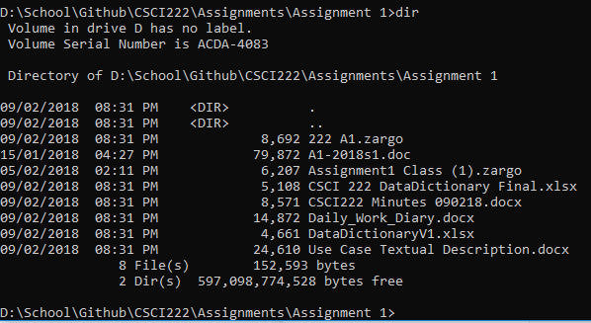
Figure C.1.1 – Screenshot of the repository in command prompt after entering Assignment 1 folder

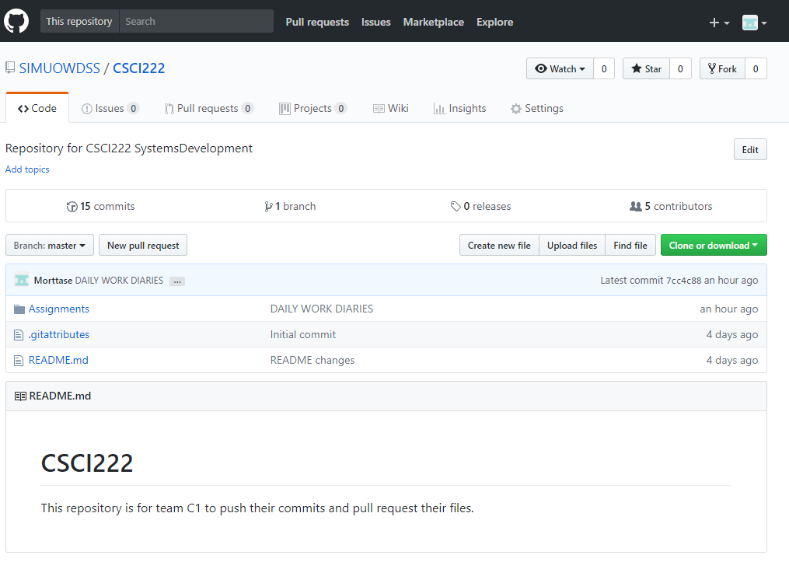
Figure C.1.2 – Screenshot of the root repository on github web.

Screenshot #2 - VCS's listing of all the latest source files currently being managed

< Paste Screenshot #2 image here >

Screenshot #3 - Example using VCS's to check-out source files (it may be necessary to do >1 screen capture, depending on the software used)

< Paste Screenshot #3 image(s) here >

Screenshot #4 - Example using VCS's to check-in source files (it may be necessary to do >1 screen capture, depending on the software used)

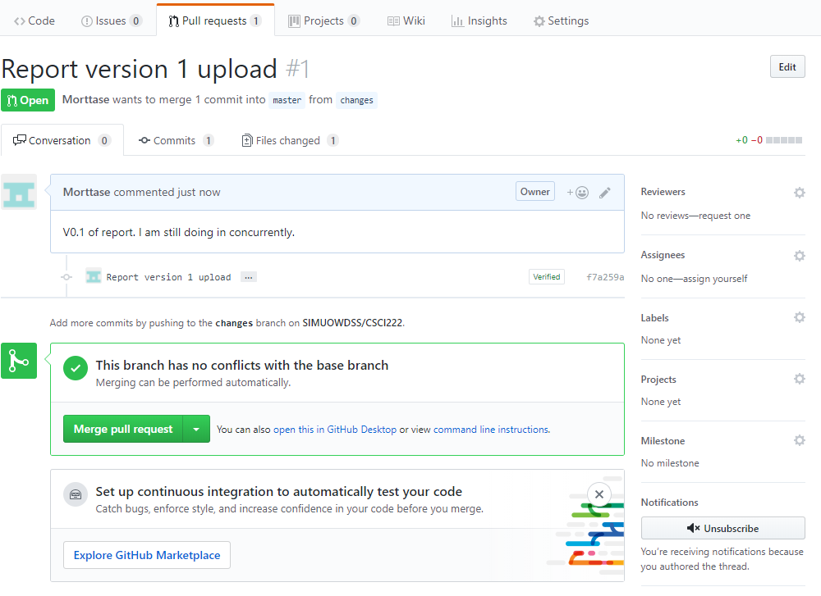
Figure C.4.1 – Screenshot showing the checking-in of source files and comparing it between 2 branches to ensure both data are equal.

Screenshot #5 - Example using VCS's to display the change history / log (it may be necessary to do >1 screen capture, depending on the software used)

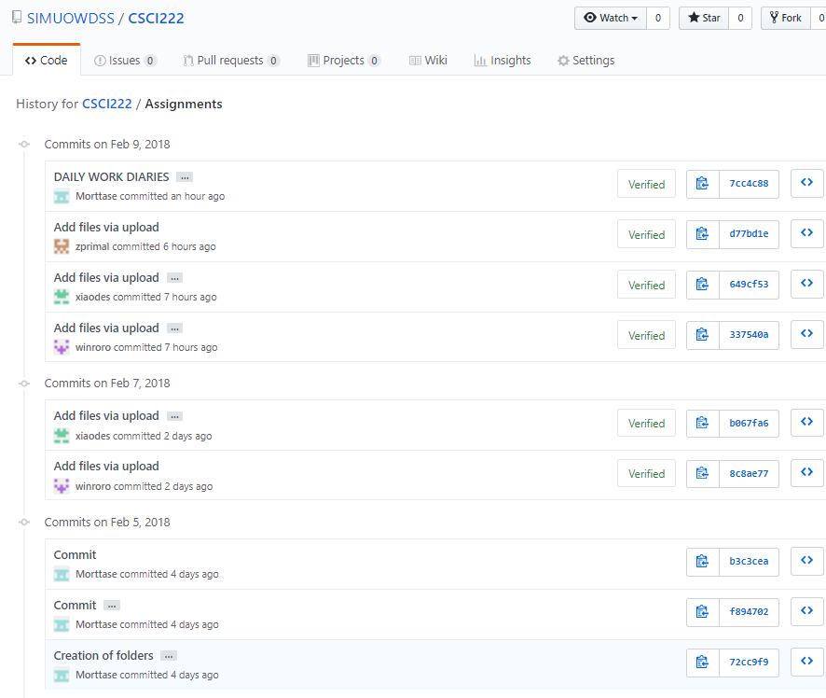
Figure C.5.1 – Screenshot that shows the history of all commits done.

